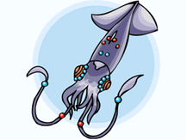
Name________________________ Partner’s Name ___________________

Squid Dissection

External Anatomy:
AFTER drawing and labeling your EXTERNAL anatomy of the squid, come to Mrs. Mullen’s desk and you will need to name the external parts of the squid verbally (without a cheat sheet).
1. Locate the water jet (siphon/funnel). The water jet is found on the ventral side of the squid.
2. The tentacles (long) and arms (short) are attached to the head of the squid.
3. Find the two large eyes on the side of the head.
4. Locate the body, which is covered by the mantle, and locate the two fins.
Compete!
Teacher’s Signature:
_________________
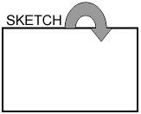
5. Each tentacle has sucker disks, count the number of sucker discs on one tentacle: _______
6. Each arm has sucker disks, count the number of sucker discs on one arm: ______
Draw the external view of the squid; Label all the parts that are underlined & bolded words above (#1-5).

Finding the Jaw
Open up the arms and remove any that are in your way. Deep in the middle of the arms is the mouth and a beak-like jaw. Use forceps to remove the jaw (beak) and lay it table so that you can draw it in the box to the right.

Analysis
1. How many arms does the squid have? ____ How many tentacles? ___
2. What is the function of the arms and tentacles? ___________________________________________________
3. What is the function of the water jet? _____________________________________________________
4. Name two features that are adaptations for the squid's predatory life. ____________________________
5. Name two traits that the squid shares with other mollusks. _____________________________________
6. To what kingdom does a squid belong? ____________________________
7. What phylum? ___________________________ What Class? _________________________
8. Name 2 other organisms in the same CLASS ___________________ & _________________________

Name________________________ Partner’s Name ___________________

Squid Dissection

External Anatomy:
AFTER drawing and labeling your EXTERNAL anatomy of the squid, come to Mrs. Mullen’s desk and you will need to name the external parts of the squid verbally (without a cheat sheet).
1. Locate the water jet (siphon/funnel). The water jet is found on the ventral side of the squid.
2. The tentacles (long) and arms (short) are attached to the head of the squid.
3. Find the two large eyes on the side of the head.
4. Locate the body, which is covered by the mantle, and locate the two fins.
Compete!
McClain’s Signature:
_________________
5. Each tentacle has sucker disks, count the number of sucker discs on one tentacle: _______
6. Each arm has sucker disks, count the number of sucker discs on one arm: ______
Draw the external view of the squid; Label all the parts that are underlined & bolded words above (#1-5).

Finding the Jaw
Open up the arms and remove any that are in your way. Deep in the middle of the arms is the mouth and a beak-like jaw. Use forceps to remove the jaw (beak) and lay it table so that you can draw it in the box to the right.

Analysis
1. How many arms does the squid have? ____ How many tentacles? ___
2. What is the function of the arms and tentacles? ___________________________________________________
3. What is the function of the water jet? _____________________________________________________
4. Name two features that are adaptations for the squid's predatory life. ____________________________
5. Name two traits that the squid shares with other mollusks. _____________________________________
6. To what kingdom does a squid belong? ____________________________
7. What phylum? ___________________________ What Class? _________________________
8. Name 2 other organisms in the same CLASS ___________________ & _________________________

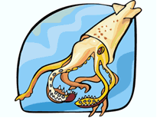
Internal Anatomy

Procedure: Turn the squid ventral side up. Pull the mantle up with the scissors where the water jet/funnel is, it should be loose and easy to pull up. Use scissors to cut from the water jet to the fins. Open the mantle to expose the structures inside.
AFTER dissecting and labeling your INTERNAL anatomy of the squid, come to Mrs. Mullen’s desk and you will need to name the external parts of the squid verbally (without a cheat sheet).
1. Find the ink sac, this is a small dark sac near the water jet. Remove the ink sac and use your dissecting needle to break the pouch. Write your initials on this paper in squid ink or just smudge the paper.
2. Find the esophagus, this is best found by looking into the mouth and seeing where it leads. The muscular mass that surrounded the beak can be pulled up (and out) to show the tube that is the esophagus
3. To find the stomach, follow the esophagus toward the posterior.
4. The anus empties into the water jet/funnel, use scissors to cut the water jet down the center so you can see the small opening of the anus.
5. Locate the gills, these are feathery structures that may be hidden under organs, there are 2 of them.
6. Follow the gills toward the interior to find an enlarged structure at their base: this is the gill heart.
7. All the way toward the fin is a whitish or yellowish structure: this is the gonad. The male gonad is generally white, the female gonad is usually more yellow to clear. Is your squid male or female? _______
8. The hard shell-like structure that lies along the backside of the squid is the pen. See if you can remove the pen in one piece. The pen serves to stabilize the squid while it swims (like our backbone).
Compete!
Teacher’s Signature:
_________________
Observations and Analysis
1. How many gills does the squid have? _________________________________________
2. Where does the ink sac empty into? ___________________________________________
3. What is its function of the ink sac? ________________________________________________________________
4. What are some functions of the water jet/siphon? ___________________________________________________
3. What is the function of the pen? __________________________________________________________________
4. Where do wastes exit the squid? (be specific) ________________________________________________________

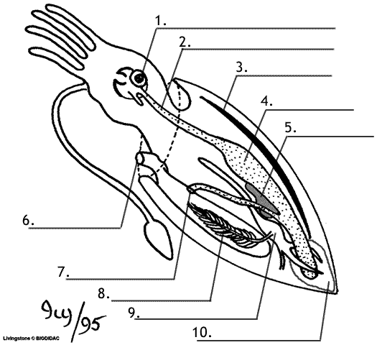
Use the descriptions above to label the squid:
Word Bank
Stomach
Ink Sack
Esophagus
Gill
Heart
Siphon/Funnel
Gonad
Eye
Beak
Anus
Pen
Arms
Tentacles

Internal Anatomy

Procedure: Turn the squid ventral side up. Pull the mantle up with the scissors where the water jet/funnel is, it should be loose and easy to pull up. Use scissors to cut from the water jet to the fins. Open the mantle to expose the structures inside.
AFTER dissecting and labeling your INTERNAL anatomy of the squid, come to Mrs. Mullen’s desk and you will need to name the external parts of the squid verbally (without a cheat sheet).
1. Find the ink sac, this is a small dark sac near the water jet. Remove the ink sac and use your dissecting needle to break the pouch. Write your initials on this paper in squid ink or just smudge the paper.
2. Find the esophagus, this is best found by looking into the mouth and seeing where it leads. The muscular mass that surrounded the beak can be pulled up (and out) to show the tube that is the esophagus
3. To find the stomach, follow the esophagus toward the posterior.
4. The anus empties into the water jet/funnel, use scissors to cut the water jet down the center so you can see the small opening of the anus.
5. Locate the gills, these are feathery structures that may be hidden under organs, there are 2 of them.
6. Follow the gills toward the interior to find an enlarged structure at their base: this is the gill heart.
7. All the way toward the fin is a whitish or yellowish structure: this is the gonad. The male gonad is generally white, the female gonad is usually more yellow to clear. Is your squid male or female? _______
8. The hard shell-like structure that lies along the backside of the squid is the pen. See if you can remove the pen in one piece. The pen serves to stabilize the squid while it swims (like our backbone).
Compete!
Mullen’s Signature:
_________________
Observations and Analysis
1. How many gills does the squid have? _________________________________________
2. Where does the ink sac empty into? ___________________________________________
3. What is its function of the ink sac? ________________________________________________________________
4. What are some functions of the water jet/siphon? ___________________________________________________
3. What is the function of the pen? __________________________________________________________________
4. Where do wastes exit the squid? (be specific) ________________________________________________________

Use the descriptions above to label the squid:
Word Bank
Stomach
Ink Sack
Esophagus
Gill
Heart
Siphon/Funnel
Gonad
Eye
Beak
Anus
Pen
Arms
Tentacles

